# FINAL DESIGN

Matthew Mahabeer - 620097948

Matthew Patterson - 620095960

Daniel Hughes - 620099840

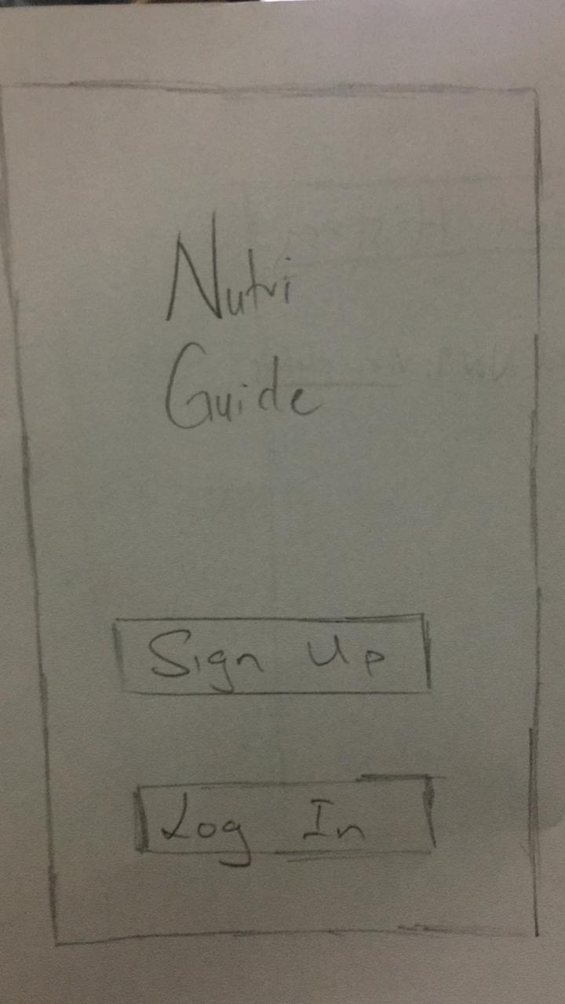

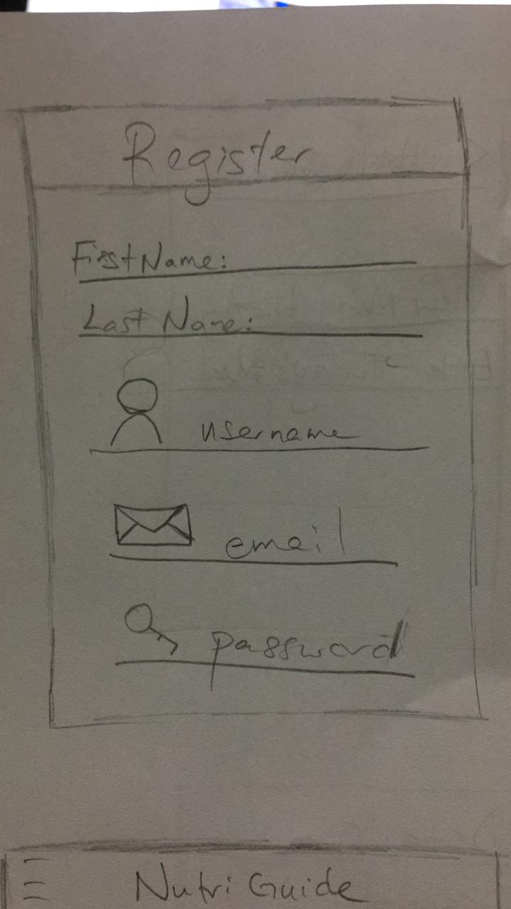

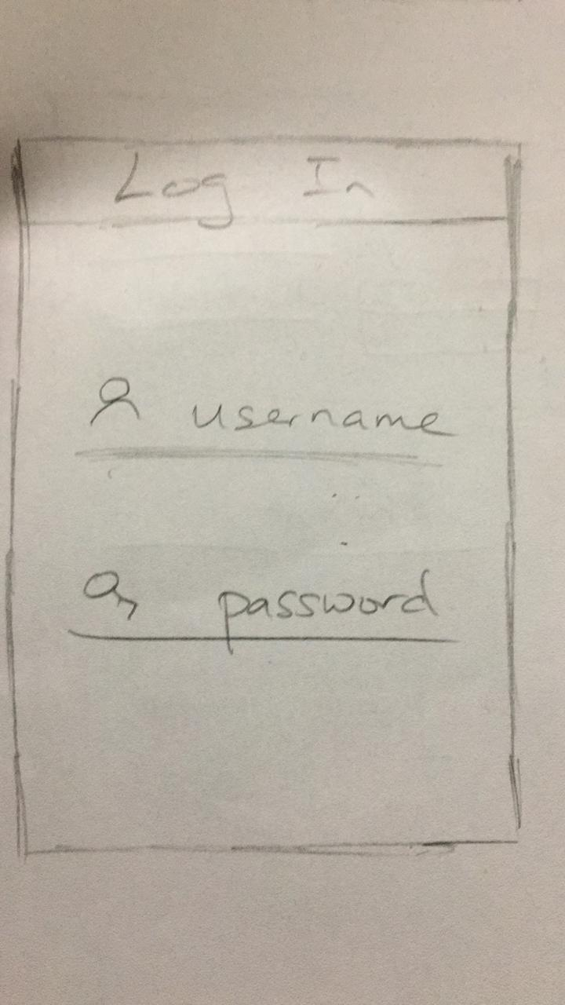

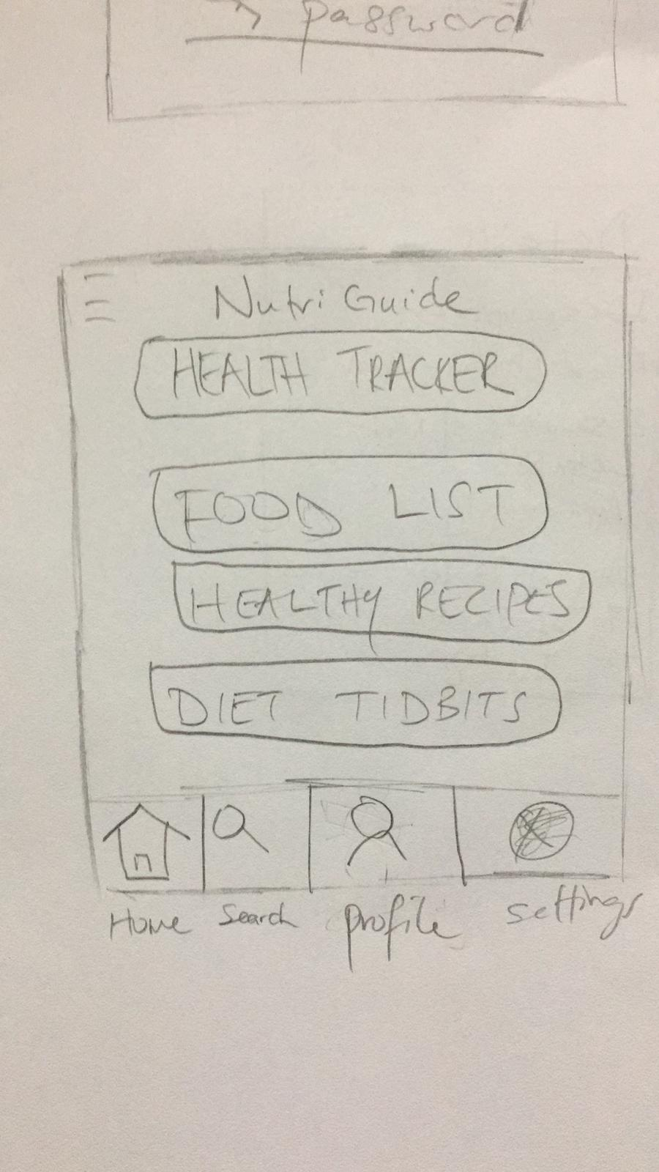

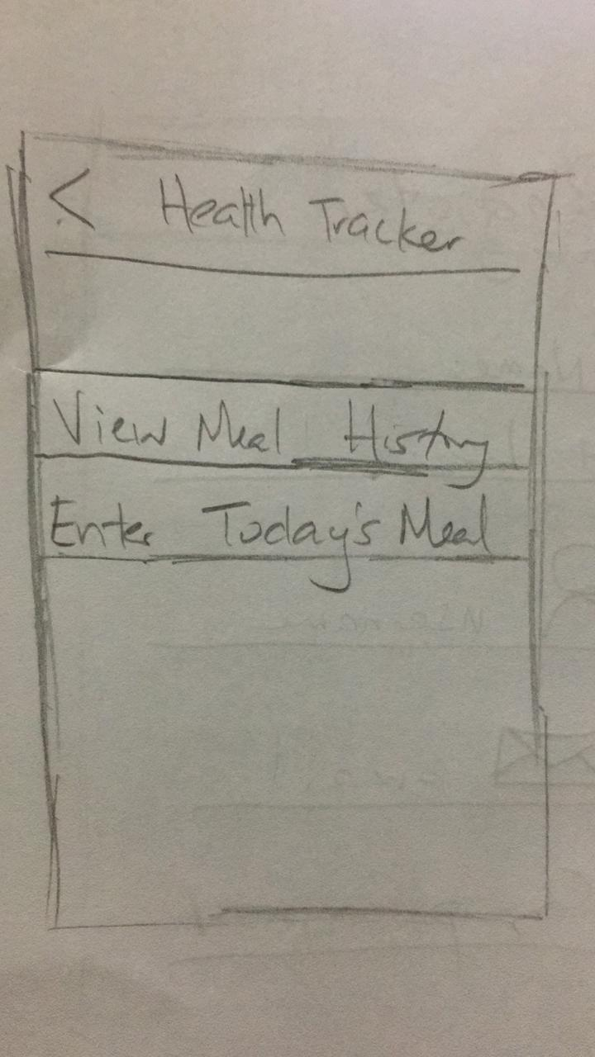

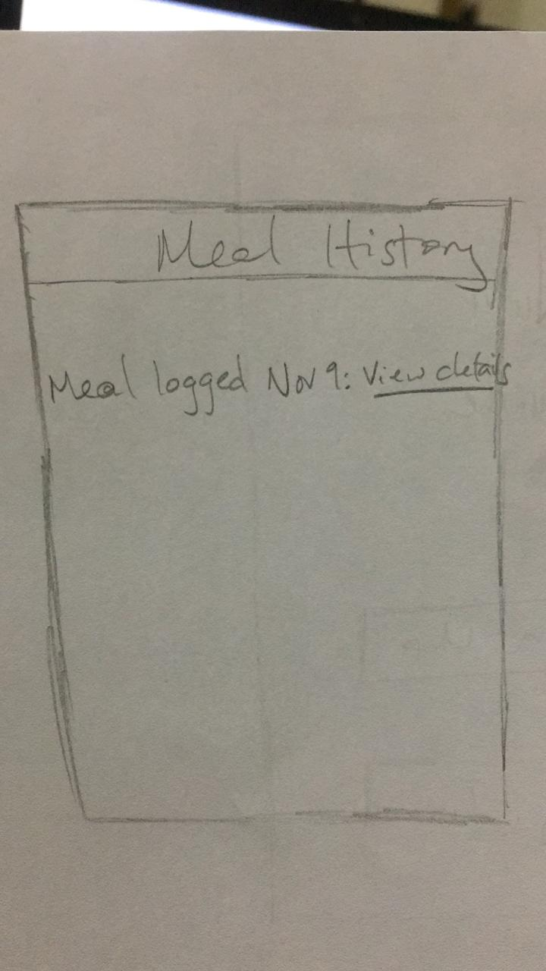

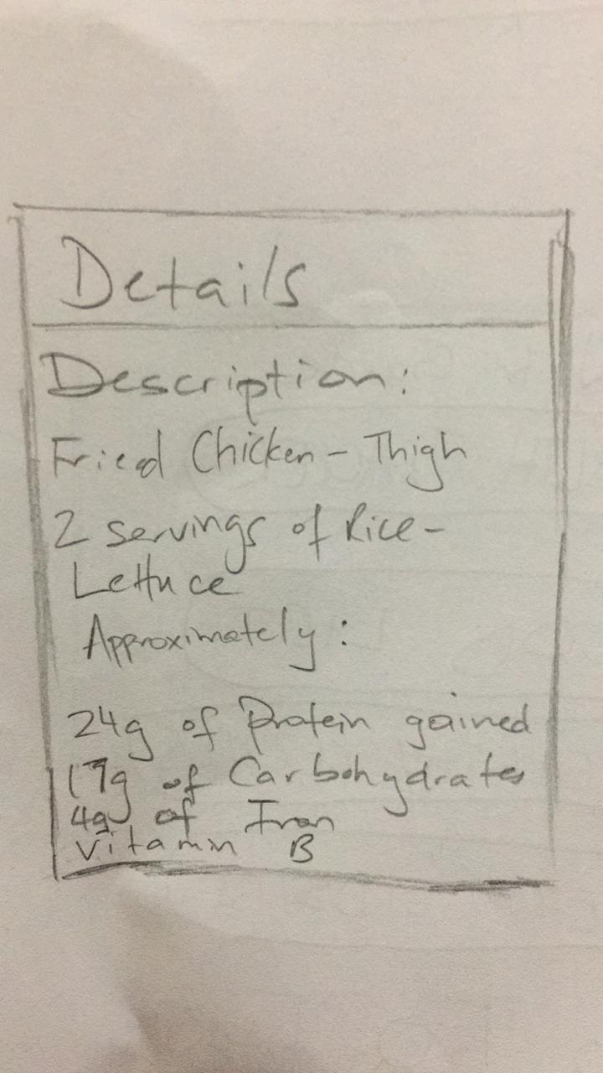

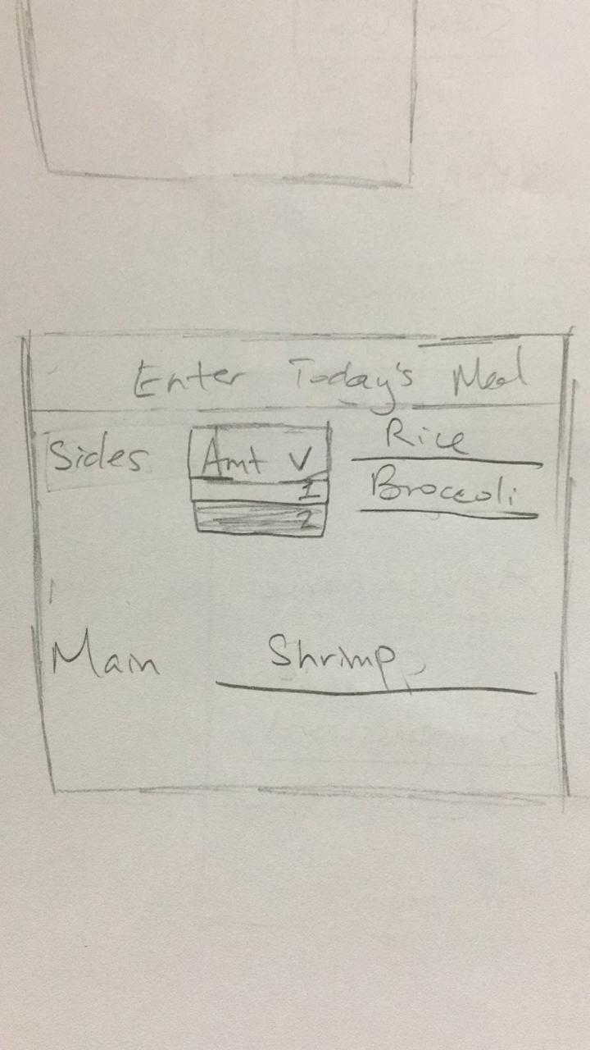

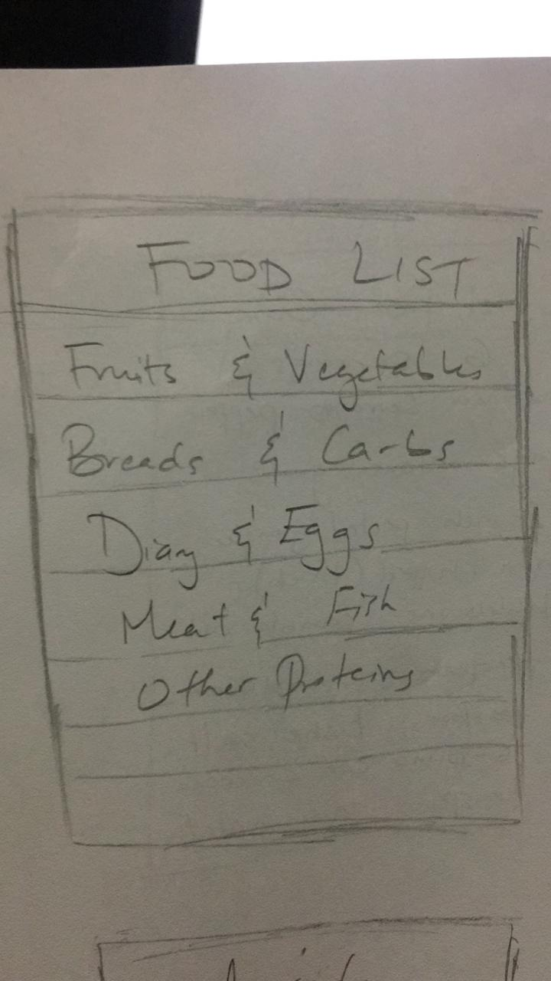

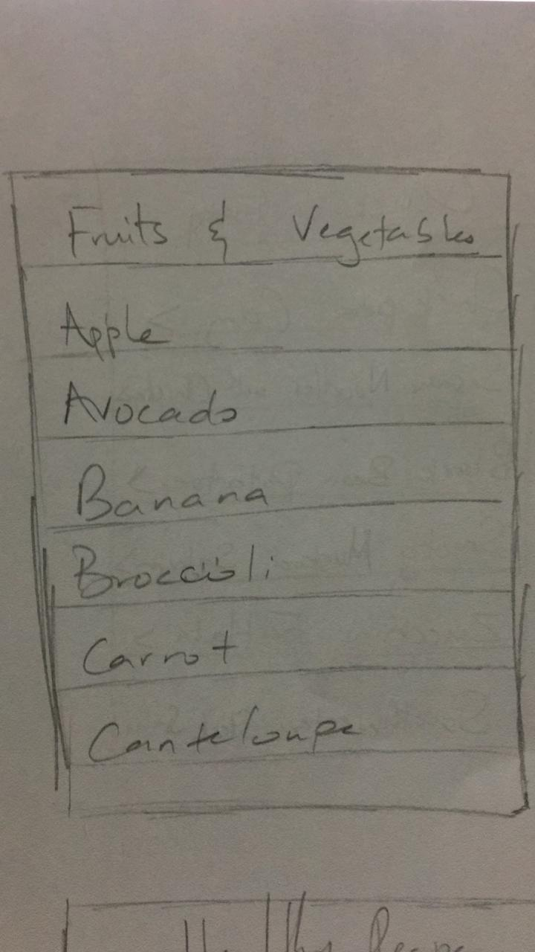

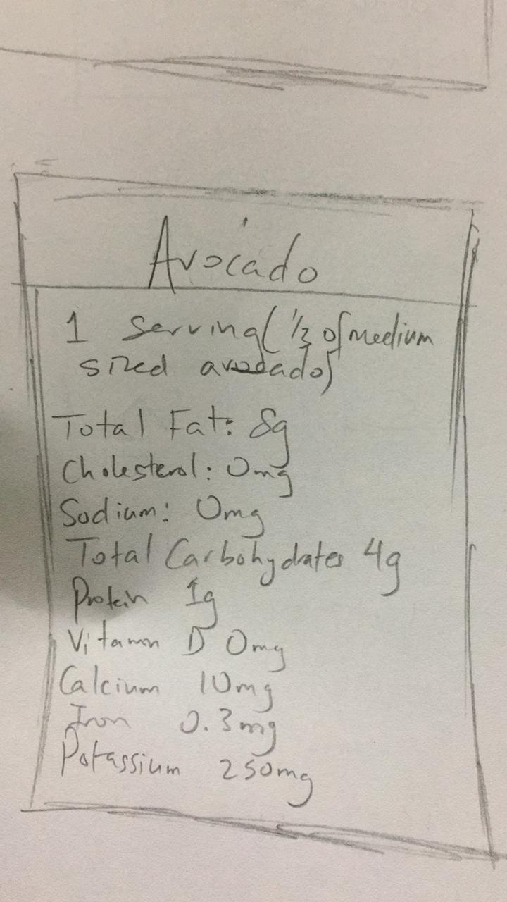

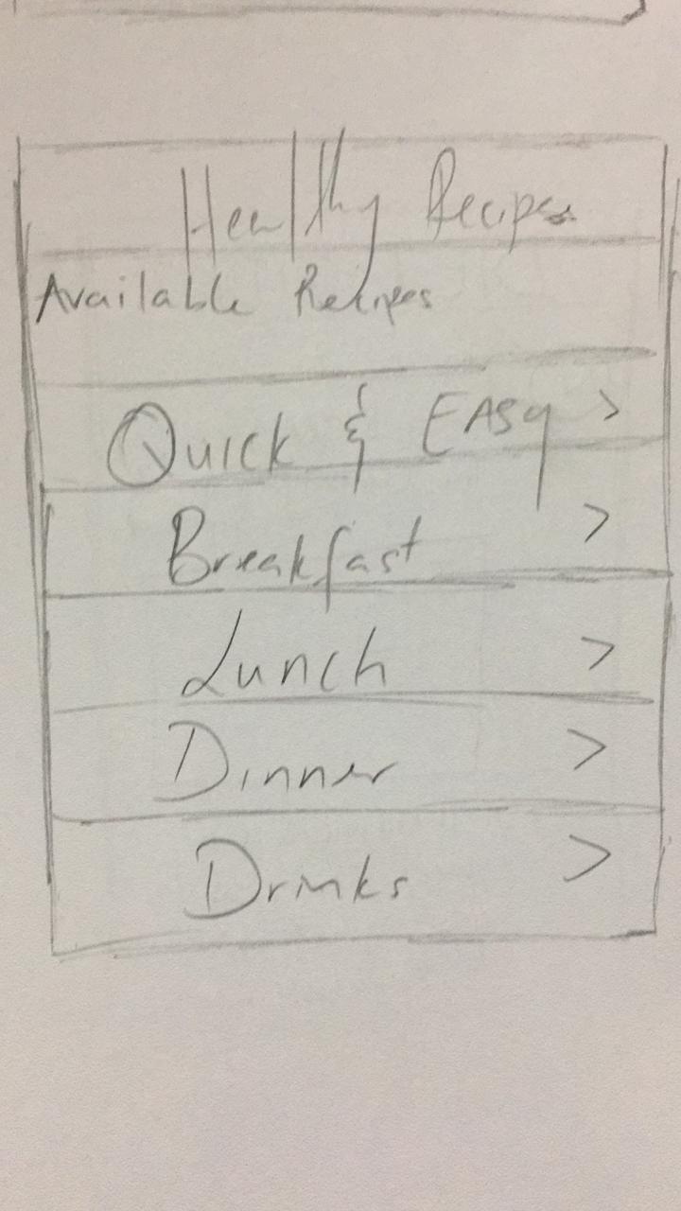

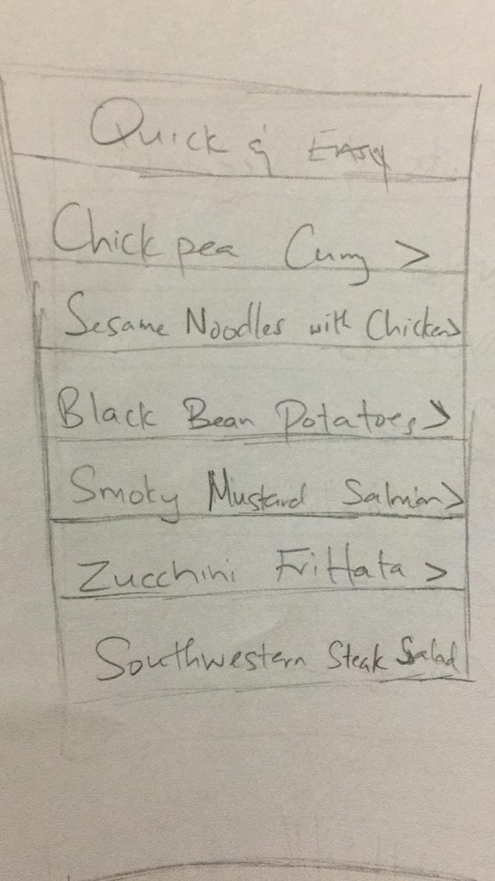

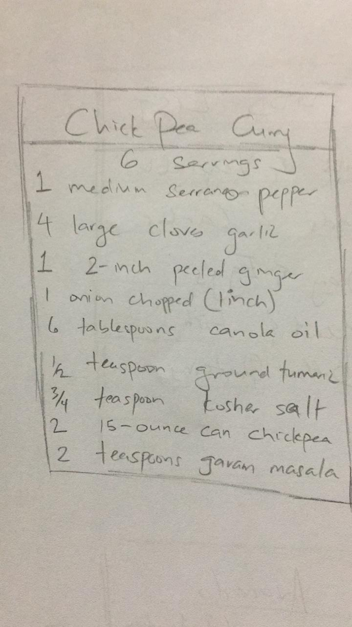

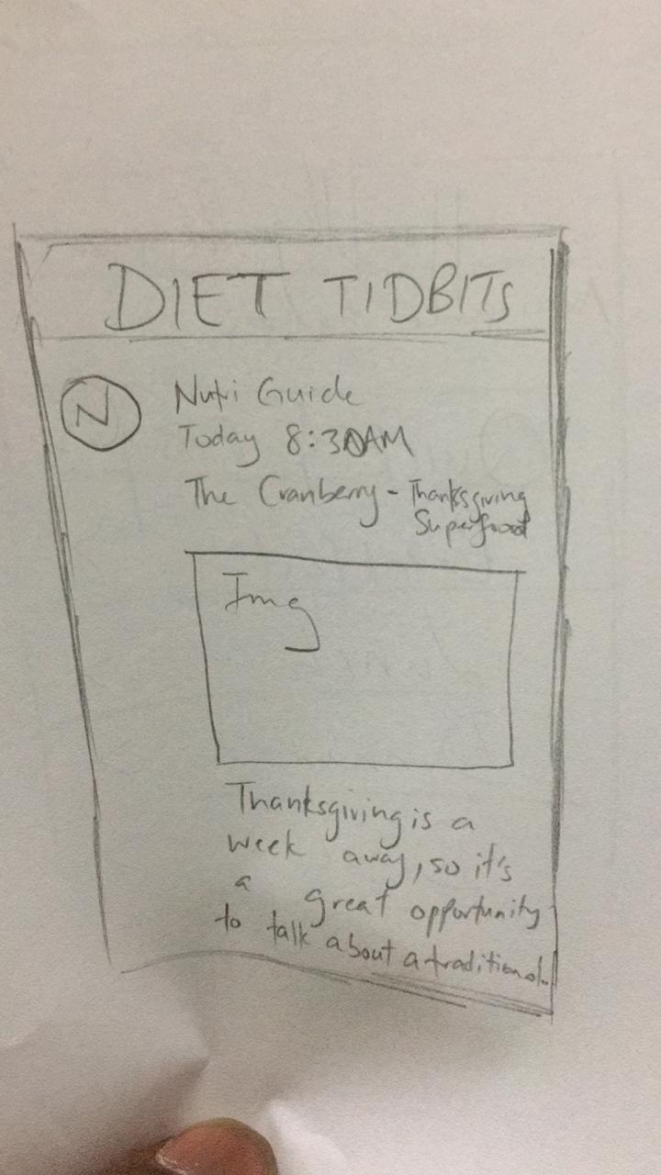

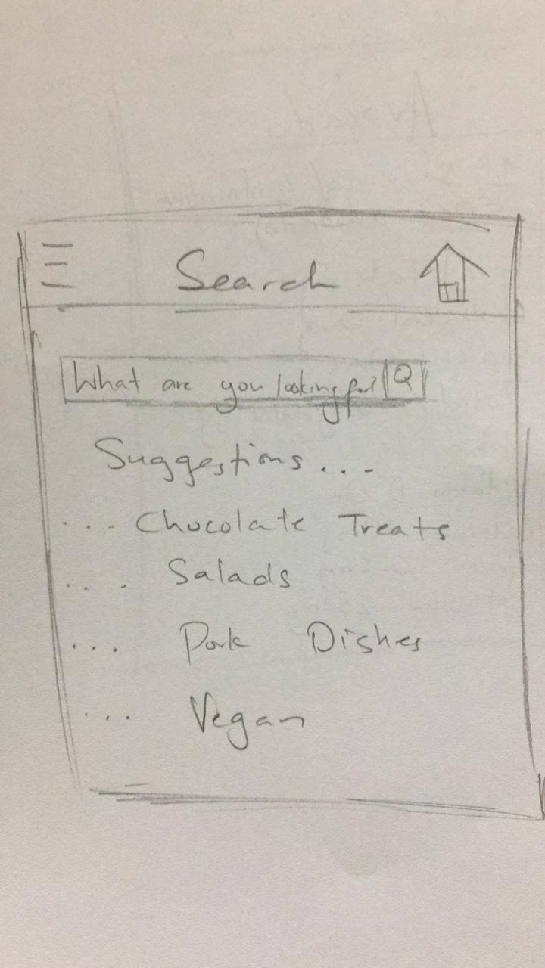

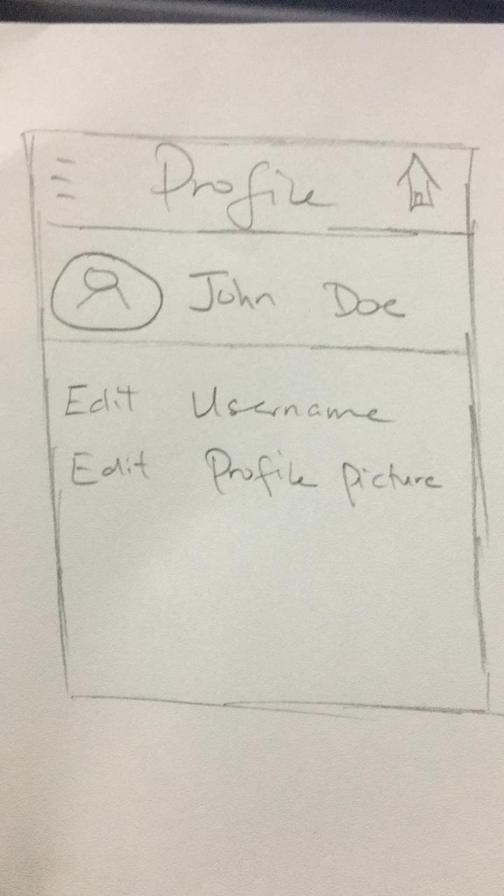

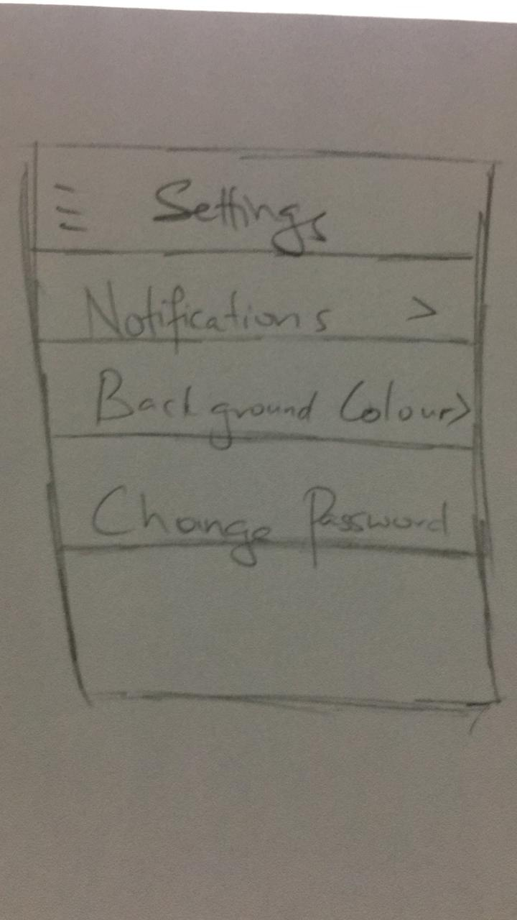

## System Chart

## Design Justification

The design layout was modeled based on the design goals set in Part 1 of this project which was set from research. The research was focused on the ease of use of applications and the usefulness and effectiveness of nutritional applications. This design takes into consideration the Important Characteristics of the Task to be performed by users. This design also observes the usability criteria.

This design also satisfies the user friendliness and forgiveness criteria.

The design of this application takes into consideration the study of rods and cones in the human eye. Specific colors are purposely used for comfort while looking at the application for extended periods of times. Icons are tabs are purposely made big to be easily seen and easily touched by users.

The navigation bar at the bottom of the application is always present. No matter which tab the user enters, the navigation bar will still be at the bottom to take them where they want to go.

The main aspect of this design is the navigation bar. It contains all the main features of the application which include Home, Search, Profile and Settings.

Users can add a meal to the list of meals he/she has eaten for nutritional tracking. The page called “Food List” allows users to easily navigate through our database for food items to both find meals and view their nutritional value. The “Food List” is ordered based on the type of meal.

The search page allows users to search the database for food items. Recipes provides a list of menu items that users can make ordered by popularity. Settings allows users to manage notifications, background colour and change their password. Profile allows users to change their display picture and password.

## Design Strengths And Weaknesses

**Strengths:**

1. The application is concentrated around Menu Tabulation for easy navigation
2. Consistent design throughout the application
3. Icons are big, colourful and easy to see. The colours that were used blend well together and are easy on the eye.
4. Minimal steps to perform tasks

**Weaknesses:**

1. The system does not have a trending page or any other way for users to interact with other users of the system.